RECIPE  
Chicken Stir Fry

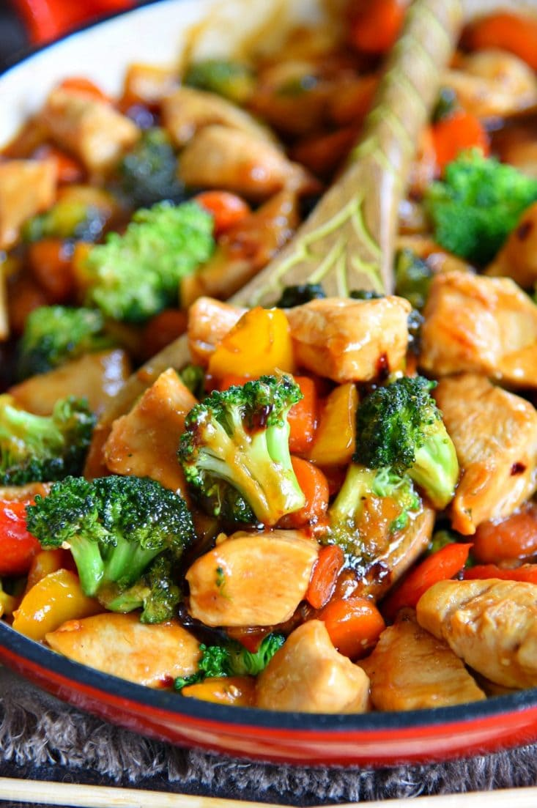

Serves **2 people**

# Tips

You can use any combination of veggies that you prefer in this recipe

# Ingredients

* 1lb Chicken Breast, cubed
* 2 Tbsp Olive Oil, divided
* 2 Cups Broccoli \**Asparagus, or cauliflower work to!*
* 1 Bell Pepper, sliced
* ½ Carrot, diced into disks \**optional*
* 1 Cup Mushrooms \**optional*
* 2 Tsp Ginger, \**Or Ginger Powder*
* 2 Garlic Clove, minced
* 1 ½ Tbsp Corn Starch
* 2 Tbsp Water
* ¼ Cup Chicken Broth
* 3 Tbsp Low Sodium Soy Sauce
* ¼ Cup Honey
* 2 Tbsp Sesame Oil
* Salt + Pepper, to taste
* Ramen Noodles/ Chow mein/ Rice Noodles/ Rice

# Preparation

1. In a small bowl, whisktogether cornstarch and water
2. Add in chicken broth, soy sauce, honey, sesame seed oil, red pepper flakes, ginger and garlic. Whisk to combine and set aside.
3. Add one tablespoon of olive oil to a large skillet or wok and heat over medium high heat
4. Add chicken and season with salt and pepper. Cook for 3 to 5 mins, until cooked through and remove from skillet.
5. Reduce the heat to medium and add the remaining tablespoon of oil to the skillet
6. Add all the veggies stir occasionally, cooking them until they are just becoming tender
7. Add the chicken back in and stir to combine
8. Whisk the stir fry sauce and pour over the chicken-veggi mix and stir to combine
9. Bring to a boil, stir occasionally until the sauce has thickened
10. Serve over rice, noodles, or my personal favorite! Cheap instant ramen noodles!!